Final Report on Monitoring ERA PRIORITIES WITH ERA ROADMAP National Action Plans

*Final Version for ERAC Plenary 10 September 2020*

*Author: Cecilia Cabello, rapporteur of the monitoring exercise*

**CONTENTS**

**Introduction** 2

**Mandate** 4

**Process** 4

**Analysis of the quantitative information** 5

Coverage of the monitoring exercise 5

Degree of execution of the actions in the NAPs 6

Assessment of the actions 7

Analysis by typology 8

**Conclusions regarding the ERA priorities** 14

Priority 1. Effective national research systems 14

Priority 2a. Jointly addressing grand societal challenges 15

Priority 2b. Research infrastructures 15

Priority 3. Open labor market for researchers 15

Priority 4. Gender equality and mainstreaming in research 16

Priority 5. Optimal circulation, access to and transfer of scientific knowledge 17

Priority 6. International cooperation 18

**FINAL REMARKS** 19

# Introduction

ERA as defined in the Lisbon Treaty and European Council Conclusions is *a unified research area open to the world based on the Internal Market, in which researchers, scientific knowledge and technology circulate freely and through which the Union and its Member States strengthen their scientific and technological bases, their competitiveness and their capacity to collectively address grand challenges*. In order to reinforce the partnership of ERA and to achieve its objectives, the **ERA Roadmap 2015-2020** was elaborated in 2015. It is important to underline that the Roadmap (like the ERA itself) covers both research and innovation.

The purpose of the Roadmap is to identify **a limited number of key priorities** which are likely to have the biggest impact on Europe’s science, research and innovation systems if all the members of the ERA Partnership get them right. Nevertheless, the ERA Roadmap was drawn up in full recognition that national research and innovation systems across Europe have different characteristics and that this variety is an asset which Europe needs to exploit to the full.

The Roadmap also proposed a number of specific key actions which might be taken to implement these priorities, whilst acknowledging that these do not necessarily represent priority actions for all Member States.

Member States have full autonomy in identifying the approaches most suited to the structures and dynamics of their national research and innovation systems when it comes to executing these actions (or other relevant priority actions at national level). The overall objective nevertheless is to implement ERA through these initiatives.

Almost all countries have developed **ERA Roadmap National Strategies and Action Plans (NAPs)**, which are important instruments to implement ERA, as recognized by the Council Conclusions. They are comprised of a set of measures, actions and initiatives which include the top action priorities of the ERA Roadmap, but also other actions that are country and context specific.

It should be noted that progress of ERA, the ERA Roadmap and the top key actions are monitored by the European Commission and reported every two years in the **ERA Progress Report**. The report shows the progress of ERA, measured by specific set of 24 indicators –that include eight headline indicators- called the ERA Monitoring Mechanism as defined by the European Research Area and Innovation Committee (ERAC). These indicators were agreed to be used to measure the top actions of each priority of the Roadmap (indicators for input, outcome and impact). The headline indicators were also endorsed by the Council.

**The progress of the implementation of the ERA priorities through the NAPs is responsibility of ERAC and the ERA related groups**, as follows:

* **Priority 1: More effective national research systems (ERAC)**. Top action priority: Strengthening the evaluation of research and innovation policies and seeking complementarities between, and rationalization of, instruments at EU and national levels.
* **Priority 2a: Jointly addressing grand challenges (High Level Group on Joint Programming–GPC)**. Top action priority: Improving alignment within and across the Joint Programming Process and the resulting initiatives (e.g. Joint Programming Initiatives (JPIs)) and speeding up their implementation.
* **Priority 2b: Making optimal use of Research infrastructures (European Strategy Forum on Research Infrastructures-ESFRI)**. Top action priority: Making optimal use of public investments in RIs by setting national priorities compatible with the ESFRI priorities and criteria taking full account of long term sustainability.
* **Priority 3: An open labor market for researchers (Standing Working Group on Human Resources and Mobility -SWG HRM)**. Top action priority: Using open, transparent and merit based recruitment practices with regard to research positions.
* **Priority 4: Gender equality and gender mainstreaming in research (Standing Working Group on Gender in Research and Innovation -SWG GRI)**. Top action priority: Translating national equality legislation into effective action to address gender imbalances in research institutions and decision making bodies and integrating the gender dimension better into R&D policies, programs and projects.
* **Priority 5: Optimal circulation, access to and transfer of scientific knowledge (Standing Working Group on Open Science and Innovation -SWG OSI)**. Top action priority: Fully implementing knowledge transfer policies at national level in order to maximize the dissemination, uptake and exploitation of scientific results. Research Public Organizations and Research Funding Organizations should make knowledge transfer second nature by integrating it in their everyday work.
* **Priority 6: International cooperation (Strategic Forum for International scientific and technological Cooperation -SFIC)**. Top action priority: Develop and implement appropriate joint strategic approaches and actions for international Science, Technology and Innovation cooperation on the basis of Member States’ national priorities.

It has been noted by ERAC Recommendations in the ERAC Action Plan 2019-2021 that monitoring the ERA priorities requires a coherent and lean monitoring tool so that it could accommodate the different national roadmaps. It recommended that it be simple, to accommodate the different national systems and situations with minimal administrative burden.

This exercise has served to monitor the **progress of ERA and its priorities based on the ERA NAPs**. It has been a collective work responsibility of all ERA related groups which have made the efforts to collect the information, analyze and report the progress.[1]

# Mandate

The updated ERAC Work Program 2019-2020, as approved by ERAC by written procedure on 5 December 2019, established that the ERAC would continue to work on its 'regular' strands, in particular the follow-up and monitoring of the implementation of the ERA NAPs, to achieve the objective of implementation by 2020, as set out in the ERA Roadmap and the NAPs.

Then, the ERAC Steering Board decided on 12 November 2019 that the ERA groups will continue their own monitoring and that a consolidated report will be prepared for ERAC plenary in 2020.

# Process

Following discussion at the ERAC Steering Board, **in 2020 delegates needed to report on the progress but also on the degree of implementation (if applicable) of the measures included in the NAPs**. A harmonized format was used to report on each priority.

**The monitoring tool approved by the Steering Board for Priority 1 and the tool developed by the GPC served as models** for monitoring the rest of the priorities:

* Priorities 1, 2b, 3, 4 and 5 used a tool (Figure 1) that gives four options to assess the progress of each action: Finished, ongoing (degree of execution greater or equal 50%), ongoing (degree of execution less than 50%) and cancelled. Additional information (with examples) on how to inform about the degree of progress has been included in tool. The template allows for the inclusion of new measures (not included in initial NAPs); this is especially relevant for Priority 5, a very dynamic field[2].
* Priorities 2a and 6 used a tool that accounts for delayed actions (Figures 2 and 3)[3]. In Priority 6 the monitoring tool developed by the task force of the GPC was adapted to fit to its needs.

A preliminary report was presented at the ERAC plenary on 4 June 2020, based on input from ERA-related groups.

Figure 1. Template for priorities 1, 2b, 3, 4 and 5

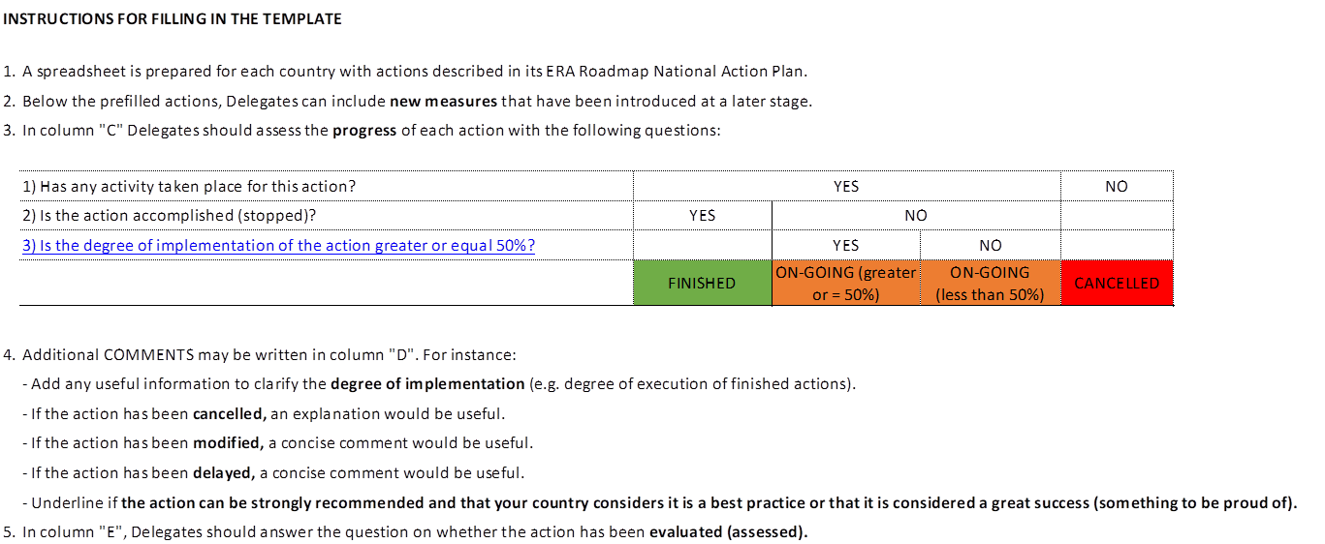

Figure 2. Template for Priority 2a

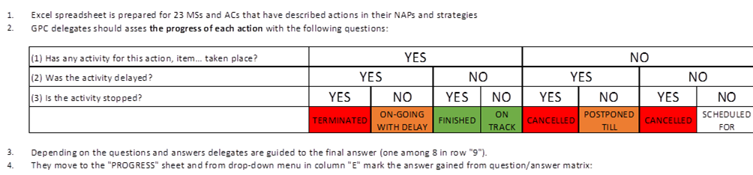

Figure 3. Template for Priority 6

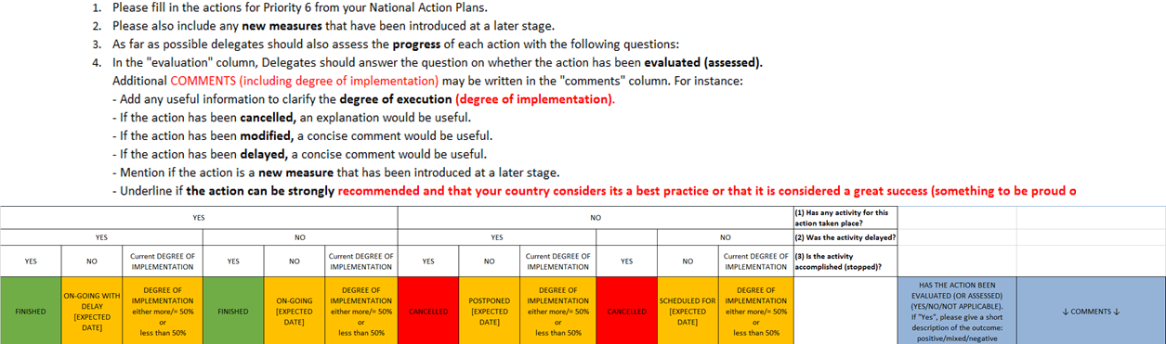

# Analysis of the quantitative information

Coverage of the monitoring exercise

There has been a strong involvement of delegations in the monitoring of their NAPs, as shown by a high general response rate: the rate of positive responses over the total of possible responses for Member States (MS) is 72% in total (27). Although Associated Countries (AC) are integral participants to the ERAC, the percentage is only calculated on the basis of the Member States to assure comparability among priorities, since the participation of associate countries in the priorities differs.

As Table 1 shows, the rate of response varies among priorities. The possible reasons for non-response may be either opting out from providing a contribution to this exercise –as this was a voluntary exercise- or the non-existence of a NAP or of actions for that particular priority in the NAP.

Priority 5 has the lowest response rate due to the fact that the NAP process is quite outdated in regard to the evolution of the Open Science and Open Innovation priorities of the SWG OSI. Moreover, as indicated by the results from the SWG OSI 2020 mini-survey on Open Science and Innovation policies at national level, Open Science plans have been put in place in at least six countries in recent years. Most probably those plans are monitored by other tools than the NAP monitoring instrument.

In summary, **the coverage is high enough to tentatively report on status and situation, as well as to indicate the degree of progress for each of the priorities**.

Table 1. Coverage[4] of the monitoring exercise (April 2020)

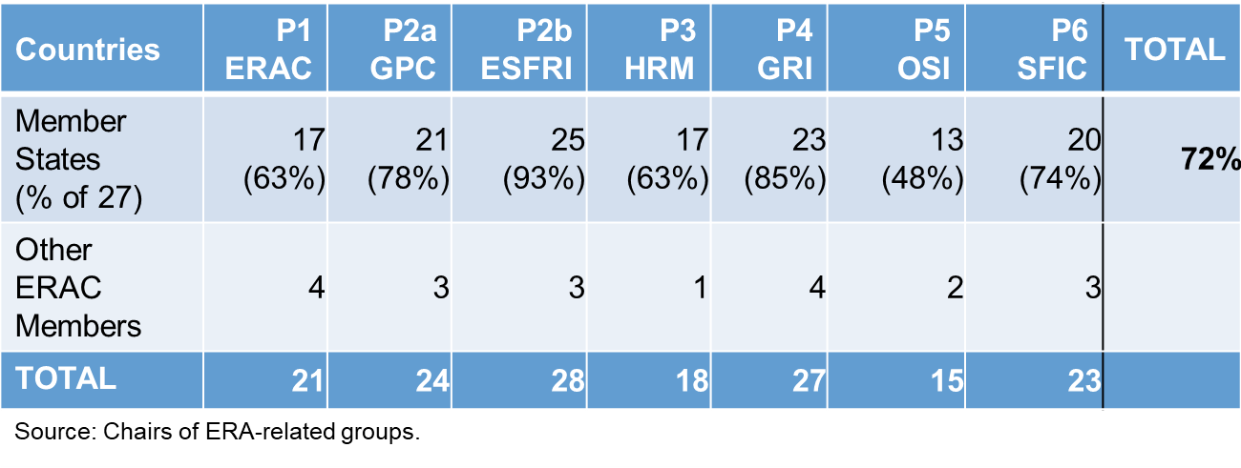

Degree of execution of the actions in the NAPs

Data on the current status of the measures can be exploited to know their degree of execution on April 2020. For those priorities using the Priority 1 monitoring tool (priorities 1, 2b, 3, 4 and 5), more than 70% of the actions are reported as finished or on on-going with a degree of execution greater or equal 50% (Table 2).

Whereas, as Table 3 shows, for those priorities using a tool based on the GPC model (priorities 2a and 6), most actions are finished or on track (on-going without delay). In Priority 2a, when only actions with known status are taken into account, 87% of the measures in the NAPs are finished or on-track = ongoing without delay.[5]

Cancelled actions do not account for more than 5% of the total number of actions in any priority.

The total number of actions for each priority, where status is known, also varies. Priority 4 has the highest number of actions and Priority 2a has the lowest[6].

Table 2. Current status of the measures by priority (April 2020). Priority 1 tool model

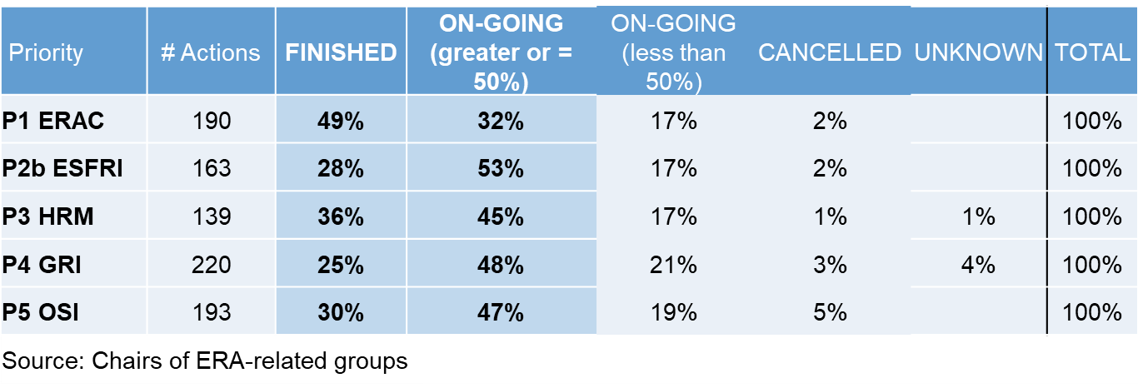

Table 3. Current status of the measures by priority (April 2020). Priority 2a tool model

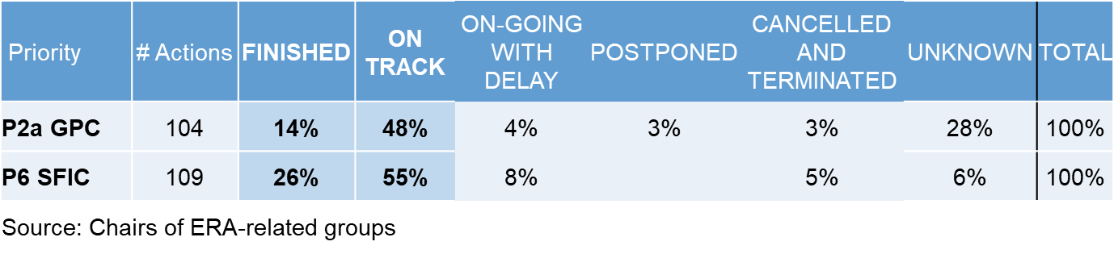

Assessment of the actions

Delegates have also reported on the assessment of the actions, and these data give a hint on the viability to monitor their results. As Table 4 shows, the ratio of assessed actions is yet very low. This implies that the evaluation aspects of the NAPs have only just started to develop. However, the ratio of assessed actions may increase slightly when the period of implementation of the NAPs ended (in December 2020, in most cases), as some countries have plans to assess the NAPs measures then.

Table 4. Measures that have been assessed or are in an ongoing assessment procedure up to now

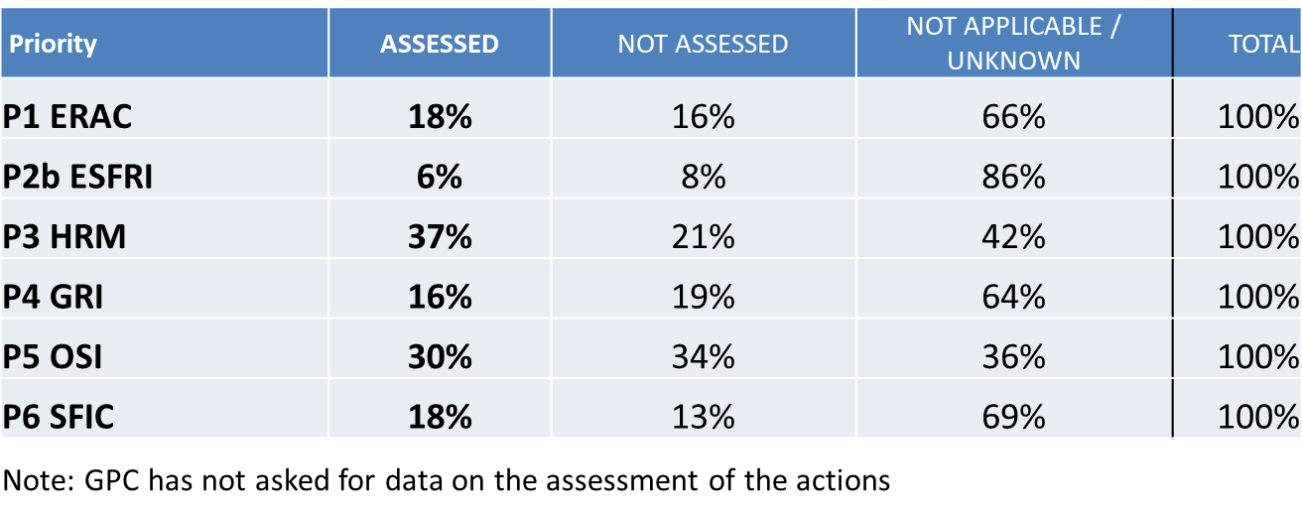

Analysis by typology

Moreover, in some priorities, measures have been classified by typology and additional information on execution is provided. Actions have been classified by typology in the monitoring process of the following priorities: Priority 1 (ERAC), Priority 2a (GPC), Priority 3 (HRM), Priority 4 (GRI) and Priority 5 (OSI)[7].

In Priority 1, effective national research systems, the measures of the NAPs have been classified by the rapporteur according to five types that were inspired from the ERA Roadmap 2015-2020. According to Table 5, measures more related to the top action priorities such as evaluation of policies and alignment of EU and national instruments account for 67% of the total number of actions included in the NAPs.

Table 5. Distribution of actions by typology in Priority 1

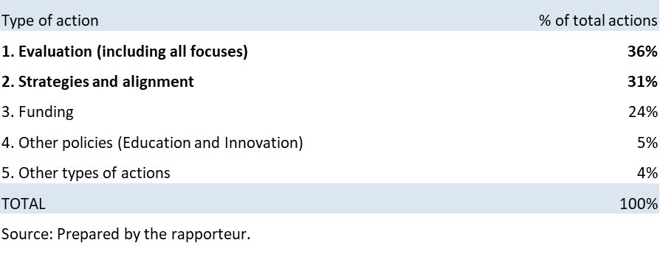

The distribution of measures by typology and the data on their current status can be exploited together to know the degree of execution by typology of the actions for Priority 1. As Table 6 shows, 84% of the measures in the Top Action Priority of the ERA Roadmap 2015-2020 (evaluation of policies and alignment of EU and national instruments) are finished or on-going with a degree of progress greater or equal 50%.

Table 6. Distribution of actions by typology and current status in Priority 1

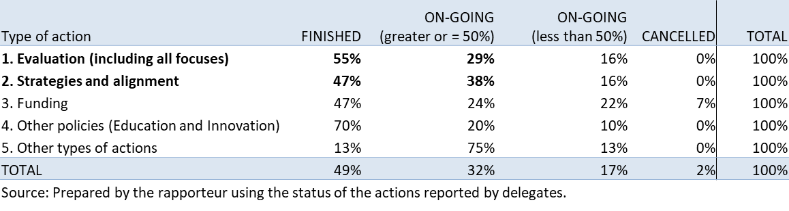

In Priority 2a, jointly addressing grand societal challenges, types are extracted from an ad hoc thoughtful text analysis of NAPs, done by the GPC. As Table 7 shows, governance issues account for 53% of the total number of actions, and include measures related to national structures for coordination, strategic networking, utilization of other instruments and alignment.

Table 7. Distribution of actions by typology in Priority 2a

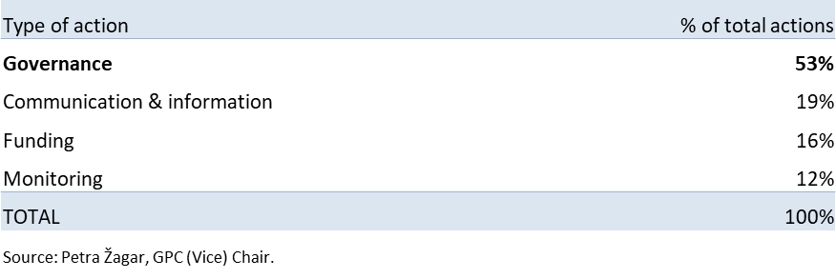

Analysis by typology and current status in Priority 2a (Table 8) shows that governance measures seem the easiest to implement, followed by funding measures. It seems that monitoring measures are not easy to implement and that communication and information measures are the hardest to implement.

Table 8. Distribution of actions by typology and current status in Priority 2a



In Priority 3, Open labour market for researchers, actions have been classified by the SWG HRM according to five implied types taken from countries’ responses. As Table 9 shows, measures to remove legal and other barriers to open recruitment and cross border access account for 53% of the total number of actions included in the NAPs.

Table 9. Distribution of actions by typology in Priority 3



When the current status of the actions is considered (Table 10), it was found that 94% of the measures to support EURAXESS are finished or on-going with a degree of progress greater or equal 50%.

Table 10. Distribution of actions by typology and current status in Priority 3



In Priority 4, gender equality and gender mainstreaming in research, the SWG GRI is using a clustering developed by the GENDERACTION Project to classify NAPs according to their comprehensiveness in terms of covering all three gender ERA equality objectives (three objectives: increasing the share of women in all fields and hierarchical levels of R&I; structural change to abolish barriers for female carriers; integration of the gender dimension in research content and teaching). The 2017 GENDERACTION Monitoring Report, completed by the SWG GRI, detected huge variability among NAPs in terms of their number of actions, comprehensiveness of the concept of gender equality and ambition:

* Comprehensive NAPs.
* Focused NAPs: context analysis, objectives and measures focus on one or two objectives.
* Actionist NAPs: no context analysis or objectives but measures.
* No NAP or NAP without Priority 4.

As Table 11 shows, countries with comprehensive and consistent, and focused NAPs for Priority 4 account for 81% of the total number of actions.

Table 11. Distribution of actions by typology in Priority 4



Analysis by typology and current status in Priority 4 (Table 12a) shows that the highest proportion of finished actions has been achieved in the actionistic NAPs for Priority 4. Comprehensive and consistent, and focused NAPs are of a more long-term nature.

Table 12a. Distribution of actions by typology and current status in Priority 4



In terms of the types of actions, the SWG GRI has developed the following clustering of actions and the distribution is shown in Table 12b:

* Monitoring and Evaluation - Monitoring/evaluation of policies or current status of gender equality in R&I;
* Strategies and Alignment - Production and implementation of R&D policies, internal regulations, Frameworks, Strategic documents, Guidelines, Taskforce;
* Other policies - Gender-related criteria for projects, differentiated assessment;
* Funding - Development/Continuation & Funding of Projects, Programmes, Gender studies courses, Awards, Charters, Prizes, etc.;
* Other types of actions - Networking, Good practice exchange, awareness raising, workshops/seminars, studies on policies.

Table 12b. Distribution of actions by thematic clusters in Priority 4



The analysis of these clusters show that the highest proportion of actions focuses on the development and implementation of strategies and policy alignment, less focus is put on Monitoring and Evaluation of policy implementation.

In terms of distribution of the actions within the three Gender Equality objectives, gender balance in research teams has the highest proportion of action (over 60% for both MS and AC); actions aimed at achieving gender balance in decision making and leadership positions account for 18% among MS and 8% among AC whereas the integration of gender dimension accounts for 17% in MS and 27% in AC.

In Priority 5, optimal circulation, access to and transfer of scientific knowledge, actions have been classified by the SWG OSI according to the sub-priorities of the Priority 5 (5A: Knowledge Transfer and 5B: Open Access). They have also been grouped by domain of action (Open Science, Open Innovation and/or Knowledge Transfer), and by thematic cluster of actions (typology).

Table 13a shows that actions are distributed in a balanced way between the 2 sub-priorities of Priority 5. As Table 13b shows, when considering the domains of action, there is a balance between Open Science and Knowledge Transfer. Actions relating exclusively to Open Innovation are very rare though, but Open Innovation as a component of Knowledge Transfer and/or Open Science actions concerns more than one action out of five.

Table 13a. Distribution of actions by sub-priority of Priority 5



Table 13b. Distribution of actions by domain in Priority 5



Distribution of the actions by thematic cluster (Table 14) further conveys that one action in three relates to the improvement of the circulation of knowledge between the various stakeholders of the knowledge society, including knowledge transfer and cooperation between academia and private companies. Only one action in twenty relates to the thematic of Open Research Data, which is in contrast with the recent and important EU initiatives in this field like the European Open Science Cloud.

Table 14. Distribution of actions by thematic cluster in Priority 5



# Conclusions regarding the ERA priorities

Data on the nature of the actions and the comments provided by delegates have served the ERA related groups to interpret the quantitative data and offer some insights and conclusions regarding each of the priorities:

Priority 1. Effective national research systems

The joint analysis of the status of the actions and their nature has given the following insights:

* Some actions have finished earlier than expected.
* Some actions are not finished because they are quite broad (e.g. improvement of the articulation of EU and national policies), their execution extends beyond 2020 or are continuous with no end at sight (e.g. consolidation of units or schemes).
* Some actions are delayed due to changes in government or intricate legislative processes, or because they depend on other delayed measures.

From the analysis of the assessment of the actions and their nature, some conclusions are that:

* Measures where assessment is applicable are usually those included in the peer reviews of the Policy Support Facility, smart specialization actions and those measures included in national strategies or plans with a monitoring mechanism.
* Most delegates report that, in actions where assessment is applicable, the examination of the measure is ongoing or planned for the near future.
* For assessed actions, the results of the examination are either positive or not yet available.

Finally, the specific analysis of the Top Action Priority (Strengthening the evaluation of R&I policies) indicates that:

* Most countries have implemented measures to:
  + Raise the aggregate standard of national policy intelligence tools (i.e. monitoring platforms, information systems, foresight activities).
  + Carry out ex post evaluation and impact assessment of R&I public policy and its main instruments.
  + Seek complementarities and align instruments at EU and national levels.
* Some countries have implemented:
  + Mutual learning activities from good international practices, using tools such as the Policy Support Facility.
  + Improved procedures for research performance assessments of public research organizations and universities.
* The recommendations of the evaluations of policies and instruments inform subsequent measures, strategies and decision-making.

Priority 2a. Jointly addressing grand societal challenges

The GPC has drawn the following conclusions from the text analysis of 29 NAPs and strategies[8]:

* **MS/AC are recognizing weaknesses in** areas that have nothing to do with the implementation of joint programming process (funding projects): **governance, coordination and outreach measures**.
* As a result, **MS/AC are focusing on national coordination** -establishment of national structures, inter-ministerial configurations of research or management models**- to achieve effective participation through transnational cooperation initiatives.**
* **MS/AC are not focusing on alignment**. Text analysis and ERA Progress Report indicate that **NAPs are not corresponding to the main challenges identified in the ERA Roadmap** (improving alignment within/across joint programing processes and speeding up their implementation).
* MS/AC think that transnational Public to Public collaboration is more effective in an EU framework than bi- or multi-lateral cooperation.

Priority 2b. Research infrastructures

* The importance of the strong involvement of delegations in the exercise (response rate: 95 %) indicates the value of **research infrastructures as a pillar in the construction of the ERA** at national level**.**
* The actions in most cases are continuous or periodic, linked to roadmapping processes and requiring more than one year for their conclusion. Reporting of a percentage of completion seems neither easy nor meaningful in these cases. However, there has been a steady increase of finished actions over time.
* Acknowledgement of the need of improving the **alignment of national priorities with those of ESFRI** **and the establishment of sufficiently stable processes** for the use of **national funding for construction and operation of RIs**.
* The need for earmarked funds to invest in and operate ESFRI RIs and especially ERICs was emphasized.
* There is general consensus among the delegations to increase the involvement of ESFRI in the achievements of National Action Plans. Statements related to the major effort made by countries to continue joining ESFRI research infrastructures are recurrent.

Priority 3. Open labor market for researchers

The joint analysis of the status of the actions and their nature has given the following insights:

* Completed activities include the establishment of funding programs (many aimed at integrating research staff in the private sector, either to do PhDs or through temporary schemes such as internships), the publication of policies/strategies/frameworks, or specific campaigns, mostly to promote **EU initiatives contributing to ERA Priority 3** (Charter & Code, HRS4R, EURAXESS Jobs, RESAVER, MSCA, etc.).

From the analysis of the types of actions some conclusions are that:

* The most common type of action reported by the countries are actions aimed at **removing legal and other barriers**. Some of these nevertheless overlap with the other types of actions as they are ultimately aimed at incorporating innovative doctoral training principles, supporting the career development and open and transparent recruitment of researchers, or facilitating the attraction and retention of international research talent.
* The second most common type of actions are those linked to **international talent attraction and retention**, with countries actively promoting the use of EURAXESS Jobs for advertising positions, but also some specific funding programs, as well as legal measures linked to the transposition of the **EU Directive 2016/801**.
* Regardless of the type of action, one clear aim that is targeted by most countries is **increasing the share of researchers in the private sector**, either by pushing forward strategies or policies increasing the capacity of enterprises to participate in research activities (particularly PhDs) or facilitating **intersectoral collaborations**. Furthermore, most actions in support of the career development of the researchers are actually aimed at facilitating **intersectoral mobility**.

Priority 4. Gender equality and mainstreaming in research

The analysis of the nature of the actions in the NAPs has given the following insights:

* Priority 4 is generally treated as an independent priority: only nine NAPs link it with at least one other priority. So gender is not integrated as a cross-cutting issue.
* Currently, different gender equality discourses inform the NAPs. Additional policy coordination in Priority 4 is needed to advance gender equality in line with the EU Gender Equality Strategy 2020-2025.[9]

From the monitoring of Priority 4, some insights are that:

* A large proportion of actions in the NAPS (over 60%) focuses on the ERA objective of gender balance in research teams overall, fewer actions focus on gender balance in decision-making and actions to foster the integration of the gender dimension in research.
* In terms of types of actions, around 40% focus on adoption of new strategies and policy alignment; in contract policy monitoring and evaluation are less frequent.
* The highest proportion of finished actions has been recorded in the actionistic NAPs for Priority 4 whereas countries with NAPS clustered among comprehensive and consistent NAPs and focused NAPs are of a more long-term nature, with some being regarded as continuous.

The following findings underscore the importance of revising the indicators to be used in the future ERA to assess progress in Priority 4:

* The cluster of countries categorized as those with good practice NAPs (comprehensive and consistent NAPs) differs significantly from the countries identified as the leading group in the ERA Progress Report 2018.[10]
* The countries in Cluster 1 or Cluster 2 for the headline indicator (share of women in Grade A positions) score below average for the implementation of gender equality plans in Research Performance Organizations.
* Furthermore, a country’s Gender Equality Index is strongly positively correlated with a higher share of research performing organizations with gender equality plans as well as the share of women in R&I boards.
* In conclusion, a meaningful set of qualitative and quantitative indicators for monitoring the NAP implementation should be developed for the next ERA.

Priority 5. Optimal circulation, access to and transfer of scientific knowledge

The analysis of the nature of the actions in the NAPs has given the following insights:

* More actions are mentioned in 2020 than in 2019: 154 in 2019 for 193 in 2020. This is an indicator of the dynamism of the field.
* There is a balance in the actions between the two sub-priorities of Priority 5: Open Access and Knowledge Transfer.
* Actions relating exclusively to Open Innovation are very rare, but Open Innovation as a component of Knowledge Transfer and/or Open Science actions concerns more than one action out of five.
* The actions relate to a broad diversity of issues that reflect the multi-dimensionality of the notions of Open Science and Open Innovation.
* One action in three relates to the improvement of the circulation of knowledge between the various stakeholders of the knowledge society. Only one action in 20 relates to the thematic of Open Research Data, which is in contrast with the recent and important EU initiatives in this field like the European Open Science Cloud.
* Countries participating in the survey cannot be strictly divided into clusters on the basis of their responses. On the contrary, the results reflect the different thematic priorities of the different countries, each of them tending to favour some OS and OI related topics at the expense of some others.
* Many OS and OI initiatives have been taken at national level in relation to the pandemic that could not yet be captured by this monitoring exercise.

Priority 6. International cooperation

When it comes to the nature of actions reported, in Priority 6 there are no defined types of actions. Although the overall diversity of actions was very high - some clear priorities have emerged:

* Almost 2/3 of the countries have reported on actions around the increase/promotion of international cooperation activities - be it through bilateral agreements and their implementation, the funding of calls, the coordination at EU level or the use of other international instruments.
* Around half of the countries have reported on actions related to prioritizing specific countries or regions, while only a few have reported also on thematic priorities.
* Around 40% of responding countries have reported on actions related to strategy and policy development in the field of international cooperation.
* Also around 40% of the countries have reported on actions related to the promotion of the country´s R&I capacities abroad, e.g. through Science Marketing, Liaison Offices or the contact with scientific Diasporas in third countries.
* The support of internationalization via their respective national research and higher education organizations as well as businesses was mentioned by around 1/4 of countries in their actions.
* High relevance of the EU Framework Program for many countries as a tool in their international cooperation efforts.
* The Strategic Forum for International Science and Technology Cooperation (SFIC) is mentioned by 30% of the countries specifically within their actions (coordination, increase of participation and boosting its relevance).

The joint analysis of the status of the actions and their nature has given the following insight: From the finished actions, most (~ 65%) relate to the set-up of / or participation in specific international programs, calls etc.; while around 11% relate to strategies, action plans etc.

Finally, the SFIC has come to the following conclusions:

* Actions in the NAPs are expressed in very different ways: precise vs. general / strategic versus operational actions.
* For the next phase of NAPs clearer guidance is needed on how to formulate actions and relate them to goals / targets etc., to be able to better assess progress.
* Delegates have found difficult to assess activities and their real status: many actions would rather be seen as continuous activities also beyond the current NAPs.

# FINAL REMARKS

The priorities defined in the ERA Roadmap 2015-2020 are working towards achieving ERA and the ERA Roadmap National Action Plans have shown that this progress is supported by on-going, long term measures and actions. Nonetheless, the monitoring exercise of the ERA Roadmap NAPs has concluded to the extent that they were defined up until 2020. At this point, the European Commission will begin a study to evaluate the current ERA policy framework in which context this report may constitute a useful contribution to the assessment. In addition, the lessons learned from the monitoring exercise may also feed into the debate and reflection on the future ERA and its governance.

1. This monitoring exercise has been led by: in Priority 2a, Petra Žagar (GPC Vice Chair); in Priority 2b, Inmaculada Figueroa (ESFRI Vice Chair); in Priority 3, Cecilia Cabello (SWG HRM Chair); in Priority 4, Marcela Linková (SWG GRI Chair) and Averil Huck (external expert); in Priority 5, Marie-Pascale Lizee (SWG OSI Vice Chair) and Marc Vanholsbeeck (Chair); and in Priority 6, Martina Hartl (SFIC Chair).
2. For Priority 2b and Priority 5, ESFRI and SWG OSI have made a short analysis comparing results in 2019 and 2020 to show how the status of the actions has evolved. For Priority 4, additional analyses were performed as part of GENDERACTION project. A Mutual Learning Workshop is planned to take place on 23 and 24 November 2020 in Vienna within the framework of GENDERACTION project to discuss NAPs implementation and recommendations.
3. GPC has made a short analysis comparing results in 2018, 2019 and. 2020.
4. Note that coverage % would be higher by eliminating the number of countries (from MS 27) that have opted out from providing a contribution to this exercise, do not have NAPs, or in the case of the SWGs do not have representatives.
5. In Priority 6, only in less than 20% of the actions delegates have used the opportunity to assess the degree of completion for the individual actions; half of the actions were assessed as being implemented more than 50% and half of the actions with less than 50%.
6. In Priority 5, delegates report 193 in 2020 for 154 actions in 2019. This shows the dynamism of the field.
7. For Priority 2b, actions were classified with Priority 1 types, but only a small number of delegations have filled the type of actions: only 17% of the Member States NAPs actions were assigned to any of the action types (None for the Associated Countries).
8. Sweden not included (info on Roadmap early May 2019).
9. For more information, please see [“SWG GRI Position Paper on the future gender equality priority in the European Research Area 2020-2030”](https://data.consilium.europa.eu/doc/document/ST-1204-2020-INIT/en/pdf)
10. For more information, please see [“Monitoring of ERA priority 4 implementation”](https://genderaction.eu/wp-content/uploads/2020/03/D3.2._MonitoringERApriority4implementation.pdf), GENDERACTION (project no. 741466),